MAST7866 – Foundations of Data Science
Assessment 1
Working out shown in non-bold black text
Final answer shown in non-bold dark blue text

1.
(a)
$$P(A∪B∪C)$$

(b)
$$(A∩B'∩C' )∪(A'∩B∩C' )∪(A'∩B'∩C)$$

(c)
$$\left(A^{'}∩B∩C\right)∪\left(A∩B^{'}∩C\right)∪(A∩B∩C')$$

(d)
$$(A∩B∩C)'$$

2.
(a)
- (i) $\frac{5}{11}$
- (ii) $\frac{9}{11}$
- (iii) $\frac{7}{11}$

(b)
1 – (pnorm(45.04, 45, 0.04) - pnorm(44.94, 45, 0.04)) $→$ 0.2254625
Therefore, probability = 22.55%

3.
(a)
Given $A∩C=0$, $B∩C=0$, $P\left(A∪B\right)=1$
$$1=P\left(A∪B∪C\right)$$
$= P(A) + P(B) + P(C) - P(A∩B) - P(A∩C) - P(B∩C) + P(A∩B∩C)$
Therefore:
$$1=\frac{1}{3}+\frac{1}{4}+\frac{1}{2}-P\left(A∩B\right)$$
$$P\left(A∩B\right)=\frac{1}{12}$$
As $P\left(A\right)⋅P\left(B\right)=\frac{1}{12}$ , $P\left(A\right)⋅P\left(B\right)=P\left(A∩B\right)$

(b)
$$P\left(A∪C\right)=P\left(A\right)+P\left(C\right)-P\left(A∩C\right)$$As $P\left(A∩C\right)= 0$: $P(A) + P(C)$

4.
(d) sort

5.
(a)
suburban <- c(58.5, 60.8, 60.6, 64.3, 64.1, 40.7, 43.7, 48.6, 49.3, 49.5)
median(suburban)
Median = 54

(b)
urban <- c(97.8, 68.3, 109.2, 78.1, 113.7, 78.6, 122.0, 84.4, 125.5, 85.3)
round(IQR(urban))
IQR = 33

(c)
sd(suburban)
sd(urban)
Suburban STDev = 8.65
Urban STDev = 20.21

Urban insurance costs vary much more than suburban costs due to a significantly larger standard deviation

(d)
boxplot(suburban, urban,
names = c("Suburban", "Urban"),
main = "Car Insurance Costs (£)",
xlab = "Cost (£)",
col = c("lightblue", "lightgreen"),
horizontal=TRUE)

Output:
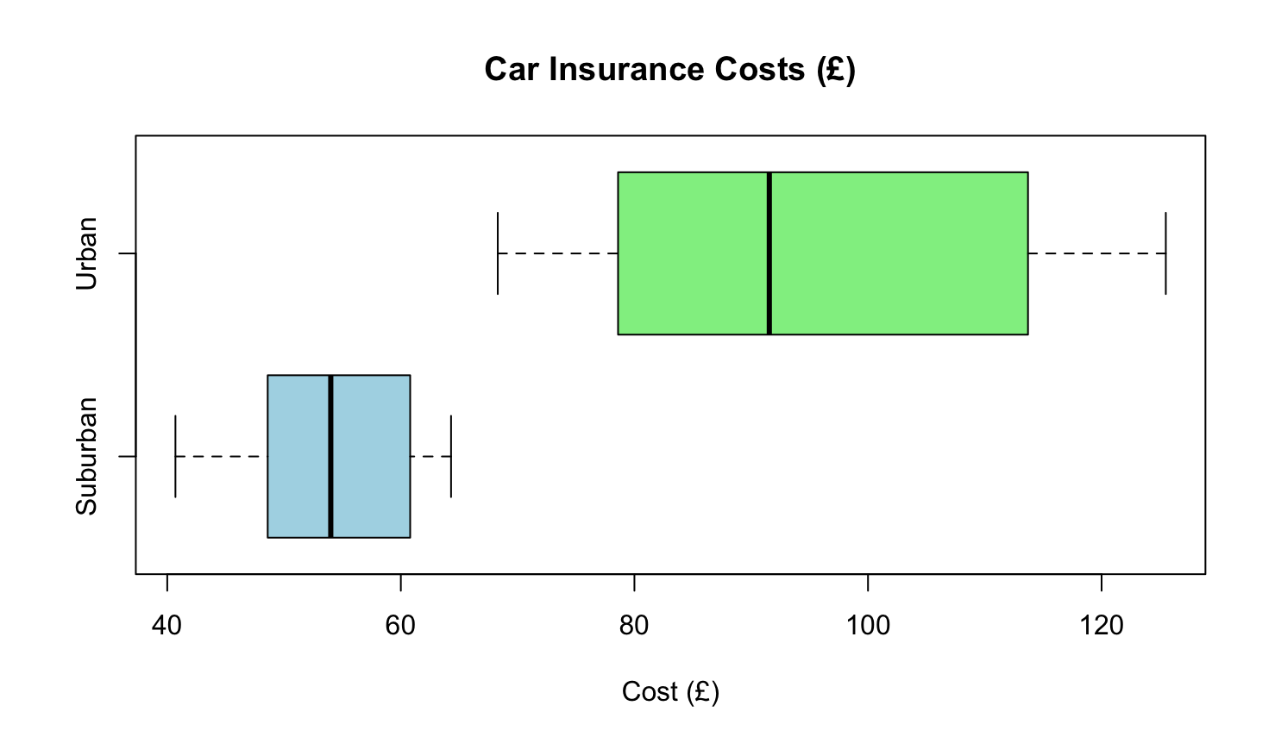
Urban costs vary significantly more than suburban costs, exhibited by the larger IQR. Urban costs are also slightly right-skewed while suburban costs are roughly symmetric with a very slight left-skew. Using the 1.5x IQR rule, there are no outliers in the suburban or urban group.

(e)
- The car insurance prices are higher in urban areas than suburban areas: True
- There are outliers in the urban dataset: False

6.
(a)
forbes <- read.table("forbes.txt", header = TRUE)
attach(forbes)

(b)
- (i)
length(age) [1] 40
length(salary) [1] 40
length(degree) [1] 40
- (ii)
sum(age<55) [1] 8
sum(salary[age<55])/sum(age<55) [1] 33.94
sum(salary|age<55)/sum(age<55) [1] 5
- (iii)
salary/age
[1] 4.5349091 3.6595238 2.1532308 2.2588333 2.0445000 1.1370423 1.2349180 1.2603509 1.2221053 1.0292537 1.1248214
[12] 0.9736207 0.9331667 0.9964583 0.7450000 0.6355385 0.6292063 0.7418868 0.6814545 0.7060377 0.6193220 0.6063333
[23] 0.6001695 0.5946552 0.7660465 0.5114062 0.5647368 0.5006349 0.4912500 0.4988889 0.5311864 0.5119672 0.5415789
[34] 0.5539623 0.5337037 0.3944444 0.5179630 0.5578000 0.4483333 0.4061290

(c)
min(age) [1] 43
max(age) [1] 72
mean(age) [1] 59.03
min(salary) [1] 25.18
max(salary) [1] 249.42
mean(salary) [1] 58.31

(d)
deg <- table(tools::toTitleCase(degree))

(e)
par(mfrow = c(1,2), mar = c(4,4,4,4))
pie(deg,
main = "Distribution of CEO Degrees",
col = RColorBrewer::brewer.pal(length(deg), "Set3"),
clockwise = TRUE,
)

axis1 <- barplot(deg,
main = "Number of CEOs by Degree",
col = RColorBrewer::brewer.pal(length(deg), "Set3"),
ylim = c(0,25),
xlab = "Degree",
ylab = "Frequency",
xaxt ="n"
)

text(x = axis1,
y = -1,
labels = names(deg),
srt = 45,
adj = 1,
xpd = TRUE,
cex = 0.9)

Output:
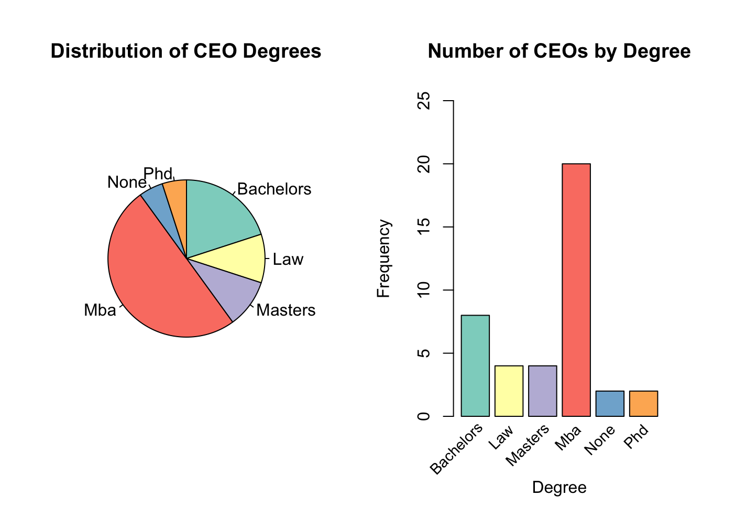
From the above graph, most CEOs have advanced degrees such as an MBA, master’s degree, law degree, or PhD. Only a small percentage hold a Bachelors (~8%) or no degree (~2.5%).

(f)
par(mfrow=c(1,1), mar = c(5,5,5,5))
plot(forbes$salary, forbes$age,
main = "CEO Age vs Salary",
xlab = "Salary",
ylab = "Age",
pch = 21,
bg = "grey",
ylim = c(30,80),
las = TRUE,
bty = "l"
)
grid()

Output:
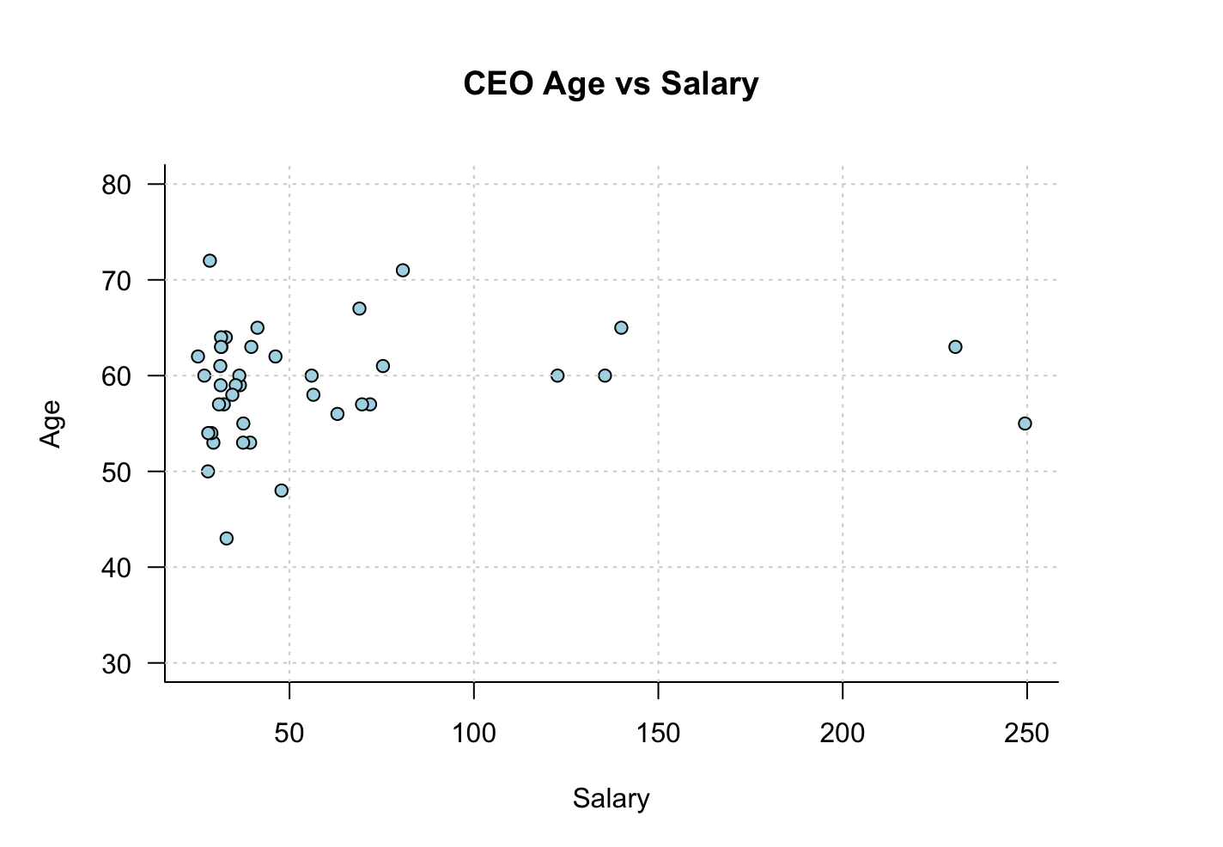

CEO salaries and ages shows a weak correlation. Most salaries range between 25-75 for CEOs between the ages of 50 and 65, with a few higher-salary outliers.

The distribution shows a non-linear pattern.

(g)
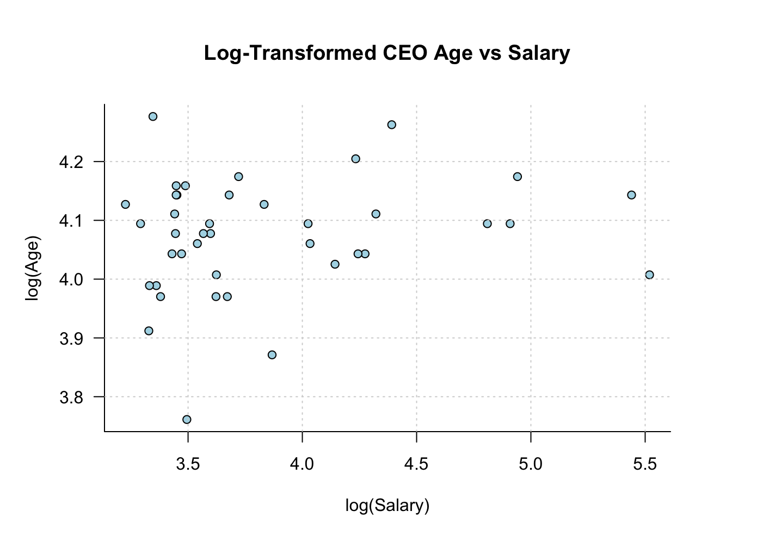

The log-transformed plot shows a weak linear relationship. Most CEO ages fall between 3.95 and 4.2, while log(salary) is more spread out, with a few higher-salary outliers.

7.
bill <- c(49,36,42,43,49,30,48,32,49,35,30,48)

sum(bill)
[1] 491
min(bill)
[1] 30
max(bill)
[1] 49

over_41 <- sum(bill > 41)
over_41 / length(bill) * 100
[1] 58.33333

Therefore, 58.33% of monthly bills were higher than 41

